Get the best out of your MILLTURN with myWFL Health Check

The WFL Health Check focuses on safety and reliability, which above all makes the overall condition of a MILLTURN visible. The WFL Health check ensures optimal performance through checking the machine geometry. With semi-automatic measurement and measurement data logging, this software or hardware offers an efficient solution that can be used on all MILLTURNs. This achieves maximum precision and productivity for the manufacturing processes.

With the latest tool called myWFL Health Check, the machine geometry is checked by semi-automatic measurement of the milling spindle and tailstock as well as the main and counter spindle. The software also includes cycles and test equipment for measuring and logging the geometry. The myWFL Health Check can be used and retrofitted on all machine types and controls, regardless of whether the machine is equipped with different special options. The entire programme takes about 25 minutes. Long-term trends can be identified thanks to the integrated measurement data logging.

The steps of myWFL Health Check

First, the roundness and alignment of the milling spindle is measured with a test mandrel in the milling spindle. This is done with different B-axis angles and different clamping states (milling spindle clamped / unclamped, B-axis clamped / unclamped, ...) The repeat accuracy of the measuring probe is then checked using the calibration ring. Next, the machine zero point is checked in the X and Y directions. The machine operator must then clamp a short shaft in the chuck to check the alignment of the headstock. In the last step, the operator clamps a long workpiece between the chuck and tailstock / counter spindle, after which the position of the tailstock / counter spindle is automatically measured in relation to the main spindle. All measurement results are stored in a measurement database and can be compared with previous measurement results.
Depending on the machine version, the Health Check program saves up to 57 measuring points in the measurement data log.

Checking the machine

The biggest advantage is the simple and regular inspection to check the machine geometry. Intervals of at least once a month are advantageous here. The timely detection of worn machine components means that repairs and maintenance work can be initiated at an early stage. This in turn saves costs and time.

And, of course, the myWFL Health Check should be carried out after every collision to see where and which parts are broken. This saves time when repairing the machine after a crash, as it is possible to immediately identify which machine components are damaged and to check whether the machine geometry is correct. Without the Health Check, checking the machine geometry is a very time-consuming process that can take several hours.

Machine efficiency is increased

In principle, the Health Check can offer a great advantage and added value for all WFL customers, regardless of their industry. The myWFL Health Check is most effective for valuable components to produce no scrap parts. The health check should be carried out before production so that rejects can be prevented and none are produced. This point is also the main benefit for WFL customer. With the myWFL Health Check, it is unlikely that rejects will be produced, which means lower production costs.

The machine geometry is checked by semi-automatically measuring the milling spindle and tailstock as well as the main and counter spindles.

To summarize, the myWFL Health Check is a quick check of the machine geometry in just a few minutes. It is a simple method to avoid scrap parts, it includes both the necessary hardware and software and thanks to the integrated measurement data logging, long-term trends can be identified. The complete health check cycle is a quick but very efficient affair and takes about 25 minutes.

The myWFL Health Check can be used and retrofitted on all machine types and control systems.

A total of six myWFL family members

In addition to the myWFL Health Check, there is also the myWFL Cockpit. This is an operating data acquisition system that displays the machine status (e.g. productive, available or fault), performance (productivity and availability), operating modes and override positions over time. Operating hours, channel status, active NC program, active tool and program runtime are also displayed. myWFL Energy is a possible extension of myWFL Cockpit with a multifunctional energy consumption meter for the power and compressed air consumption of the entire machine. This allows the current power and energy consumption data to be determined and displayed over time, as well as the energy consumption per workpiece. And with the option of an integrated condition monitoring cycle, significant changes between the new condition and the current condition can be checked.

A new feature is myWFL Reporting. With this software, reports can be created automatically and events for trigger types can be programmed manually, time-controlled or program-controlled. The myWFL e-mail messenger is currently in the development phase. This includes an alarm message function with e-mail notification of the machine status over the last eight days. The e-mail also contains additional information on the alarm or the current tool. In conjunction with M016-15-13 myWFL Cockpit, further information can be called up via the link sent in the e-mail.

The latest TECtalk highlights the topic of myWFL Health Check. You can watch the interview on YouTube.

Contact:
WFL Millturn Technologies GmbH & Co. KG
Wahringerstraße 36, A-4030 Linz
Tel. +43 732-6913-0
www.wfl.at

Photos:

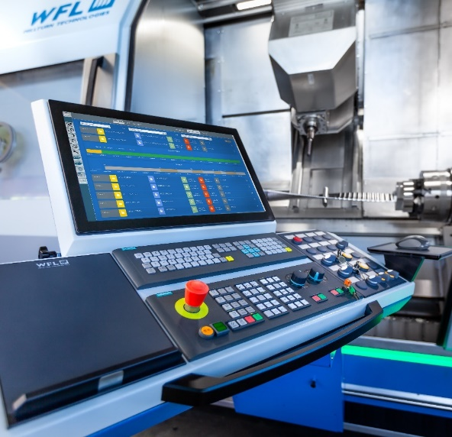

01: The dashboard overview displays data such as machine status, performance, operating modes and override positions over time, as well as operating hours, channel status, active NC program and much more.

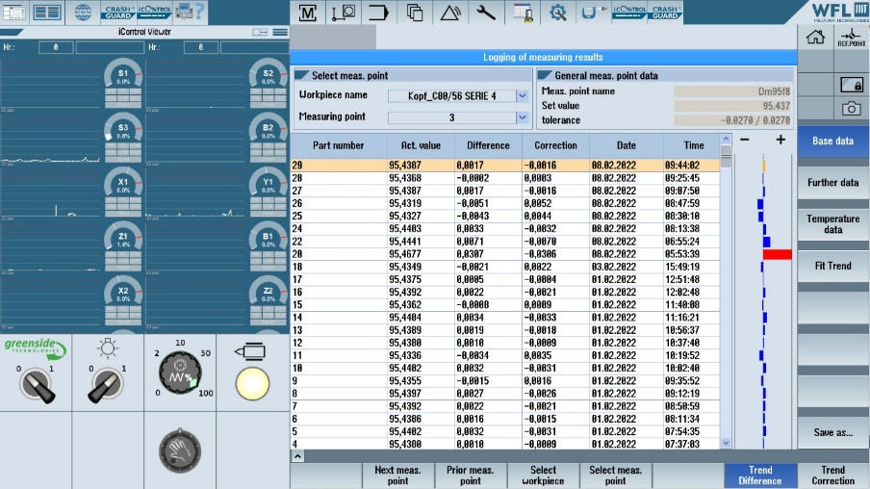

02: The myWFL Health Check can be used and retrofitted on all machine types and control systems.

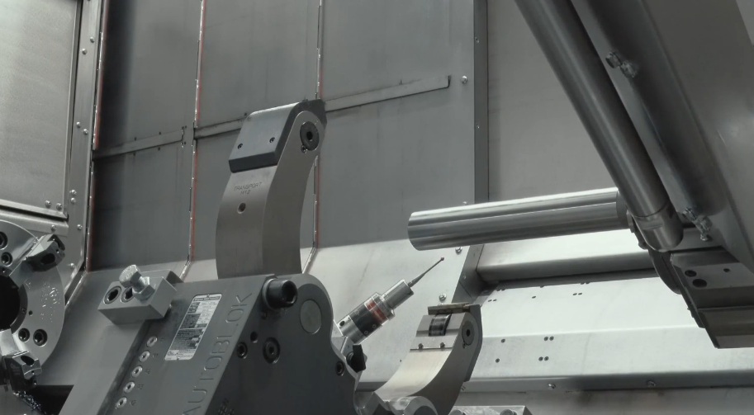

03: The concentricity and alignment of the milling spindle are measured with a test mandrel in the turning-boring-milling unit.

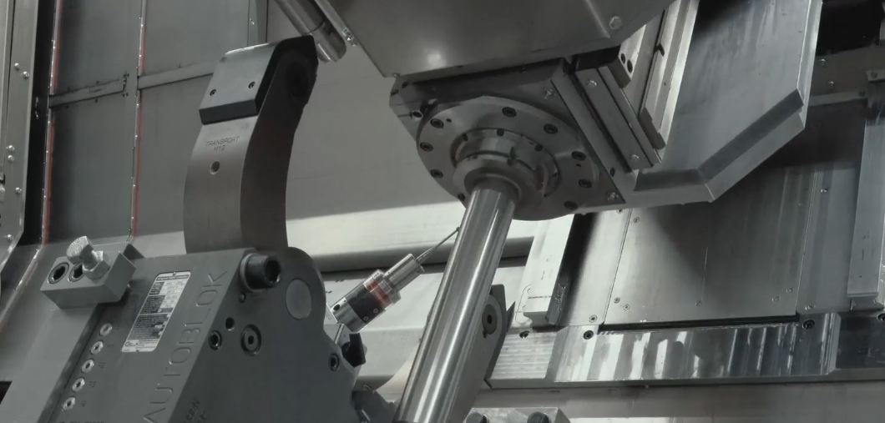

04: This is done with different B-axis angles and different clamping states (milling spindle clamped/unclamped, B-axis clamped/unclamped, ...).

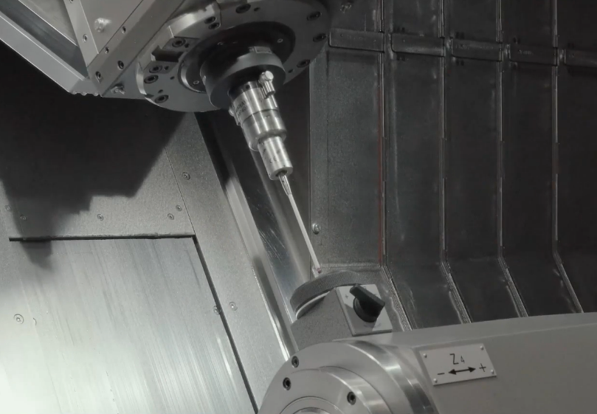

05: The repeat accuracy of the probe is then checked using the calibration ring. The workpiece probe is calibrated and checked for repeat accuracy.

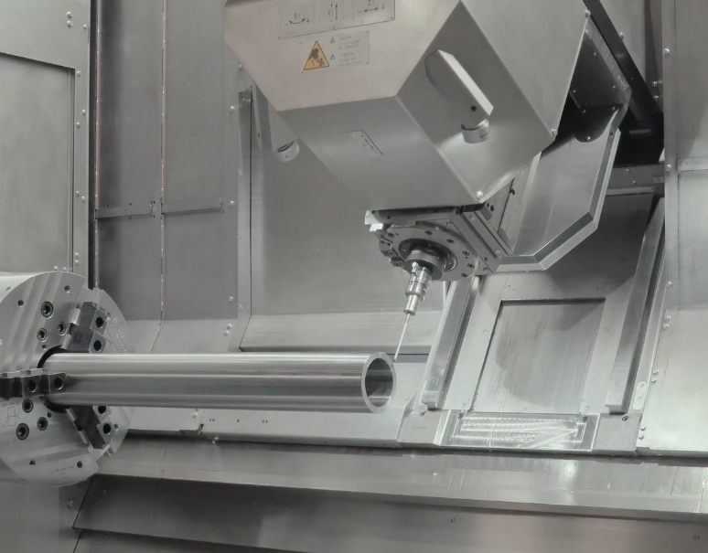

06: The X and Y axes are checked against the zero point. After inserting a short workpiece into the chuck, the headstock alignment is checked automatically.

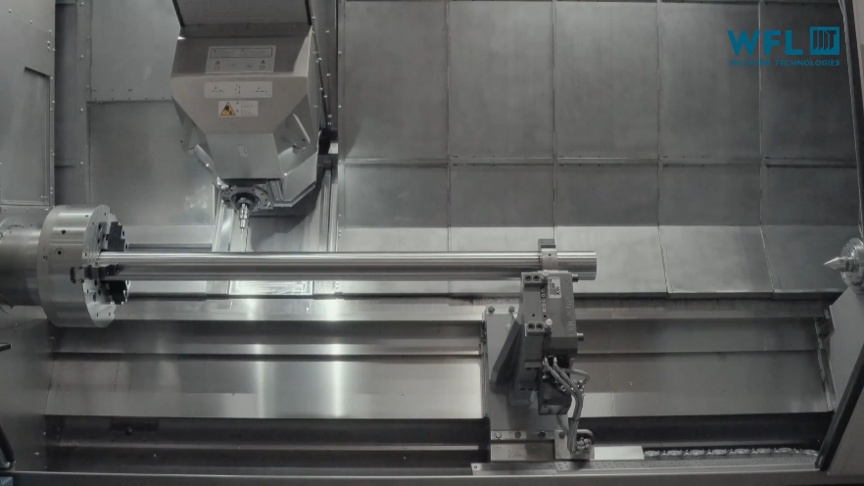

07: After clamping a long workpiece in the chuck and tailstock, the position of the tailstock in relation to the main spindle is automatically measured (also available for counter spindle).

